**39**

**Introduction to Quantum Physics**

|  |
| --- |
| **CHAPTER OUTLINE** |

39.1 Blackbody Radiation and Planck’s Hypothesis

39.2 The Photoelectric Effect

39.3 The Compton Effect

39.4 The Nature of Electromagnetic Waves

39.5 The Wave Properties of Particles

39.6 A New Model: The Quantum Particle

39.7 The Double-Slit Experiment Revisited

39.8 The Uncertainty Principle

* An asterisk indicates a question or problem item new to this edition.

|  |
| --- |
| **ANSWERS TO THINK-PAIR-SHARE ACTIVITIES** |

**\*TP39.1 Conceptualize** Imagine the system of the Earth exchanging energy: energy comes in by electromagnetic radiation from the Sun, and goes out by electromagnetic radiation from the surface. There are *no* other energy exchanges.

**Categorize** The Earth is modeled as a *nonisolated system in steady state,* since we assume the surface has reached a fixed temperature.

**Analyze** (a) Equation 8.2 becomes, for this situation,

 (1)

We can write an energy balance equation in terms of power by differentiating this equation with respect to time:

 (2)

Stefan’s Law, Equation 39.1, can be used for the output power:

 (3)

where the minus sign indicates that energy is leaving the system of the Earth. For the input power, use the definition of intensity, Equation 16.38:

 (4)

where *IS* is the intensity of solar radiation at the Earth, and *A*circle is the circular cross section of the Earth perpendicular to the Sun. We modify Equation (4) by noting that 30.0% of the incoming radiation is reflected away and does not contribute to warming the planet. Therefore, we include only the remaining 70.0%:

 (5)

Substitute Equations (3) and (5) into Equation (2) and evaluate the circular cross section and surface area of the Earth in term of its radius *RE*:

 (6)

Solve Equation (6) for the equilibrium temperature *T*:

 (7)

Substitute numerical values:



(b) Solve Equation (6) for the emissivity *e*:

 (8)

Substitute numerical values for the current global average temperature of 288 K:



(c) In Equation (7), substitute numerical values; include an emissivity 5.00% smaller than that in part (b):



**Finalize** The answer to part (c) represents a 4 K temperature increase for the surface of the Earth, or 7.2°F, with only a 5.00% change in emissivity. This temperature change would be disastrous, with catastrophic effects on weather patterns, agriculture, melting glaciers, sea level rise, etc. The results of this problem hopefully demonstrate the importance of efforts to slow down climate change on the Earth.]

*Answers:* (b) 0.615 (c) 292 K

**\*TP39.2 Conceptualize** Review Section 39.2 to make sure you are clear on the details of the photoelectric effect.

**Categorize** The emitter and an electron ejected from the emitter can be modeled as a *nonisolated system* for *energy,* leading to Equation 39.11.

**Analyze** Add two columns to the table, using Equation 16.12 to find the frequency of the light striking the emitter and Equation 24.4 to find the work done by the electric field in stopping the ejected electron, the negative of which is the maximum kinetic energy of the ejected electrons:

|  |  |  |  |
| --- | --- | --- | --- |
| **Wavelength of Light Striking the Emitter (nm)** | **Stopping Potential (V)** | **Frequency of Light Striking the Emitter (1014 Hz)** | ***K*max (eV)** |
| 546.1 | 0.53 | 5.49 | 0.53 |
| 433.9 | 1.08 | 6.91 | 1.08 |
| 404.7 | 1.27 | 7.41 | 1.27 |
| 365.0 | 1.66 | 8.22 | 1.66 |
| 312.6 | 2.20 | 9.60 | 2.20 |
| 253.5 | 3.11 | 11.8 | 3.11 |

Now, graph the energies in the last column against the frequencies in the third column:

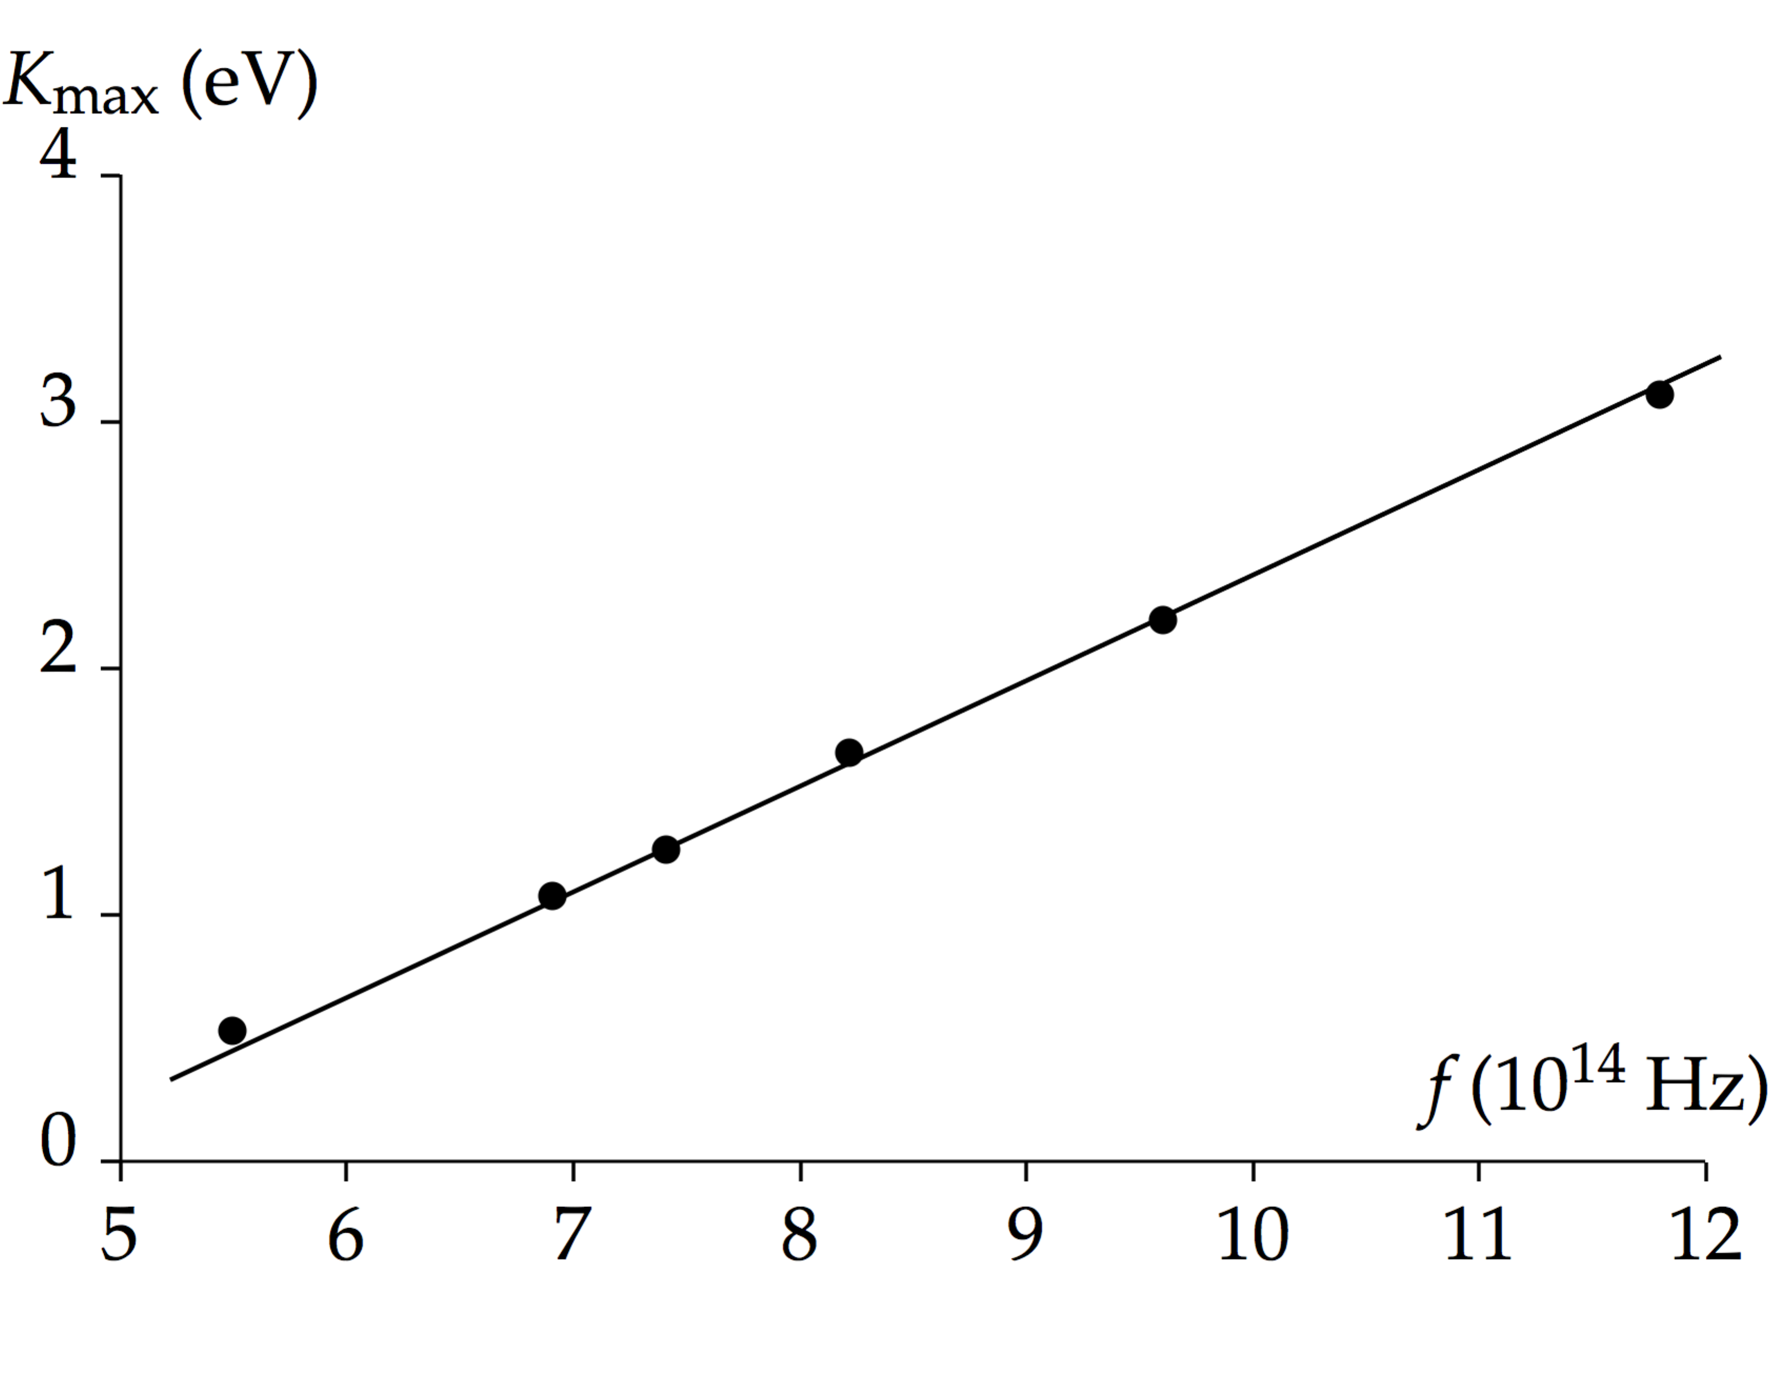

A best-fit calculation of the slope of this data shows that



**Finalize** This value is quite close to the currently accepted value. ]

*Answer:* 6.6 × 10–34 J · s

|  |
| --- |
| **SOLUTIONS TO END-OF-CHAPTER PROBLEMS** |

**SWERS TO THINK-PAIR-SHARE ACTIVITIES**

**Section 39.1 Blackbody Radiation and Planck’s Hypothesis**

**P39.1** (a) For lightning,



For the explosion,



(b) Lightning: ultraviolet; explosion: x-ray and gamma ray

**P39.2** (a) From Equation 39.2,



(b) The wavelength emitted at the greatest intensity is in the infrared (greater than 700 nm), and according to the graph in Active Figure 40.3, much more energy is radiated at wavelengths longer than  than at shorter wavelengths.

**P39.3** Each photon has an energy



This implies that there are



**P39.4** (a) The peak radiation occurs at approximately 560 nm wavelength. From Wien’s displacement law,



(b) Clearly, a firefly is not at this temperature, so 

**P39.5** (a) From Stefan’s law (Equation 39.1),  If the sun emits as a black body, *e* = 1.



(b) 

P39.6 (i) Planck’s equation is E = hf. The photon energies are:

(a) 

(b) 

(c) 

(ii) Wavelengths:

(a) 

(b) 

(c) 

(iii) Part of spectrum:

(a) 

(b) 

(c) 

**P39.7** (a) The mass of the sphere is



(b) From Stefan’s law,





(c) It emits but does not absorb radiation, so its temperature must drop according to





(d) 



(e) 

(f) The energy output each second is carried by photons according to



Matter is coupled to radiation quite strongly, in terms of photon numbers.

**P39.8** (a) From Stefan’s law,



(b) From Wien’s displacement law,



(c) We compute:



The power per wavelength interval is

,

and





(d)–(i) The other values are computed similarly:



(j) We approximate the area under the *P*(*λ*) versus *λ* curve, between 400 nm and 700 nm, as the product of the average power per wavelength times the range of wavelength:



**P39.9** (a) The physical length of the pulse is



(b) We find the number of photons from



Then,



(c) The volume of the beam is



The number of photons per cubic millimeter is



**P39.10** Planck’s radiation law is

.

For long wavelengths, the exponent  is small. Using the series expansion



Planck’s law reduces to



which is the Rayleigh–Jeans law, for very long wavelengths.

**Section 39.2 The Photoelectric Effect**

**P39.11** (a) The cutoff wavelength is given by Equation 39.12:



which corresponds to a frequency of



(b) We find the stopping potential from 



Therefore, 

**P39.12** (a) The energy needed is *E* = 1.00 eV = 1.60 × 10–19 J.

The energy absorbed in time interval  is



So,



(b) The result for part (a) does not agree at all with the experimental observations.

**P39.13** (a) At the cutoff wavelength, the energy of the photons is equal to the work function (*K*max = 0):



(b) This is the cutoff frequency:



(c) The maximum kinetic energy is the difference between the energy of the photons and the work function:

 

**P39.14** (a) The energy of photons is



(b) The photon energy is larger than the work function.

(c) 

(d) 

**Section 39.3 The Compton Effect**

**P39.15** We note that .

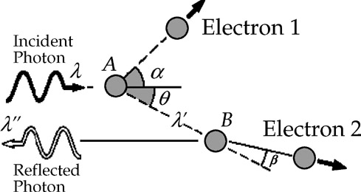

**ANS. FIG. P39.15**

At *A*, the scattering angle is *θ*, and



At *B*, the scattering angle is 180° – *θ*, and



Therefore,



**P39.16** (a) and (b) From  we calculate the wavelength of the scattered photon. For example, at *θ* = 30° we have



The electron carries off the energy the photon loses:



The other entries are computed similarly.

|  |  |  |  |  |  |  |  |
| --- | --- | --- | --- | --- | --- | --- | --- |
| ***θ***, **degrees** | 0 | 30 | 60 | 90 | 120 | 150 | 180 |
| ***λ'***, **pm** | 120.0 | 120.3 | 121.2 | 122.4 | 123.6 | 124.5 | 124.8 |
| ***Ke***, **eV** | 0 | 27.9 | 104 | 205 | 305 | 376 | 402 |

(c) 

**P39.17** With *Ke* = *E*′ and *Ke* = *E*0 – *E*′, we have .

We also have  therefore, 

By the Compton equation,



Therefore,



**\*P39.18 Conceptualize** When the x-ray photons scatter from the electrons, they transfer some energy to the electrons. The lower-energy photons then have a longer wavelength than they had initially.

**Categorize** We model the x-ray photon and the electron as an *isolated system* for both *energy* and *momentum,* leading to the Compton shift equation, Equation 39.13.

**Analyze** (a) In Equation 39.13, let the scattered wavelength be some factor *f* multiplied by the original wavelength, and solve for the scattering angle:

 (1)

Substitute numerical values, recognizing that a 1.2% increase is represented by *f* = 1.012:



(b) To find the longest wavelength, solve Equation 39.13 for the scattered wavelength:

 (2)

Now, let ** be 180°:

 (3)

Substitute numerical values:



**Finalize** The longest possible wavelength is about 4.2% longer than the original wavelength. Notice from Equation (2) that the maximum change in the wavelength is generally equal to twice the Compton wavelength.]

*Answers:* (a) 64.4° (b) 0.120 nm

**P39.19** The photon has momentum  before scattering and momentum  after scattering. The electron momentum after scattering is *pe*.

(a) Conservation of momentum in the *x* direction gives



or  **[1]**

Conservation of momentum in the *y* direction gives



which (neglecting the trivial solution *θ* = 0) gives

 **[2]**

Substituting [2] into [1] gives



or  **[3]**

Substitute [3] into the Compton equation:





Solving,



(b) Using equation [3]:



Then,



(c) From energy conservation:



From equation [2],



**P39.20** The photon has momentum  before scattering and momentum  after scattering. The electron momentum after scattering is *pe*.

(a) Conservation of momentum in the *x* direction gives



or  **[1]**

Conservation of momentum in the *y* direction gives



which (neglecting the trivial solution *θ* = 0) gives

 **[2]**

Substituting [2] into [1] gives



or  **[3]**

Substitute [3] into the Compton equation:











(b) Using equation [3]:



Then, 

(c) From energy conservation:





From equation [2],



**P39.21** We treat the electron non-relativistically because



The electron’s final kinetic energy is

.

This is the energy lost by the photon:

 **[1]**

From the Compton equation, we have

 [2]

 **[3]**

Substitute [2] and [3] into [1]:



Solving,



(a) Solve for :





Only the positive answer is physical:



(b) From [3],



Substituting,



The electron scattering angle is *φ*. By conservation of momentum in the transverse direction:



P39.22 (a) 

(b) Assuming the photon is incident along the *x* direction, the equations are

 [1]

and



Dividing the latter two equations gives

 **[2]**

Substituting equation [2] into equation [1] gives



**Section 39.4 The Nature of Electromagnetic Waves**

**P39.23** With photon energy *E* = *hf* = 10.0 eV, a photon would have



and





**P39.24** The photon energy is



The power carried by the beam is



Its intensity is the average Poynting vector



(a) To find the electric field, we use



Solving,



(b) 

(c) Each photon carries momentum . The beam transports momentum at the rate . It imparts momentum to a perfectly reflecting surface at the rate



(d) The block of ice absorbs energy  melting



**Section 39.5 The Wave Properties of Particles**

**P39.25** (a) 

(b) From 



**P39.26** Since the de Broglie wavelength is  the electron momentum is:



(a) For electrons, the relativistic answer is more precisely correct. Suppressing units,





(b) For photons (suppressing units):



**P39.27** (a) From 



(b) We find the momentum of the particle from



Then,



(c) The electron’s wavelength is



(d) The wavelength is two orders of magnitude smaller than the size of the nucleus.

**P39.28** (a)  or less, so  or more. The energy of the electron is, suppressing units,



or  or more

so that

 or more

(b) If the nucleus contains ten protons, the electric potential energy of the electron-nucleus system would be



(c) With its  the electron could not be confined to the nucleus.

**\*P39.29 Conceptualize** Review Example 39.5 regarding the calculation of a wavelength for an electron.

**Categorize** We are considering the wave nature of an electron in this problem, as opposed to its particle nature.

**Analyze** For the fringe patterns to be the same, the electrons must have the same wavelength as the red light. Begin with Equation 39.18, and express the electron speed *u* in terms of its kinetic energy *K*:

 (1)

Solve Equation (1) for the kinetic energy of the electrons:

 (2)

Substitute numerical values:



Therefore, the electrons must be accelerated through 3.76 **V to have the correct wavelength.

**Finalize** This is a small voltage. A wavelength of 632.8 nm for an electron requires only a relatively low speed, about 1 150 m/s. Compare this result to that in part (A) of Example 39.5. There, the wavelength of the electron is

*λ* = 7.27 × 10−11 m = 0.072 7 nm

This is smaller than the wavelength in this problem by a factor of 8.70 × 103, requiring a speed that is higher by that factor:

(1 150 m/s)(8.70 × 103) = 1.00 × 107 m/s

as in Example 39.5. The voltage required to accelerate the electron in Example 39.5, ignoring relativistic effects, is 284 V, a factor of (8.70 × 103)2 higher than the 3.76 **V voltage required in this problem.]

*Answer:* 3.76 **V

**39.30** (a) *E*2 = *p*2*c*2 + *m*2*c*4 with *E* = *hf*,

 and 

Substituting, we find that

 and 

(b) No. For a photon,  The third term  in the equation above for particles with mass shows that they will always have a different frequency from photons of the same wavelength.

**P39.31** Given the assumption in the problem statement, for significant diffraction to occur, we must have



where *u* is the speed of the student as he passes through the doorway. The variable we do not know here is the speed *u*, so let’s solve for it:



This expression will give the upper limit to the speed of the student. Substitute numerical values:



This is an extremely low velocity. It is impossible for the student to walk this slowly. At this speed, if the thickness of the wall in which the door is built is 15 cm, the time interval required for the student to pass through the door is 1.4 × 1033 s, which is 1015 times the age of the Universe.

**Section 39.6 A New Model: The Quantum Particle**

**P39.32** (a) The particle is freely moving, so we attribute no potential energy to it. Its energy is

**

For its momentum we have

**

Thus,



Then the phase speed is



(b) We see that the phase speed is only one-half of the experimentally measurable speed *u* at which the quantum particle transports mass, energy, and momentum. In the textbook’s Active Figure 27.16, individual wave crests would move forward more slowly than their envelope moves forward, so individual crests would appear to move backward relative to the packet containing them.

**P39.33** As a bonus, we begin by proving that the phase speed  is not the speed of the particle.



In fact, the phase speed is larger than the speed of light! A point of constant phase in the wave function carries no mass, no energy, and no information.

Now for the group speed:



It is this speed at which mass, energy, and momentum are transported.

**Section 39.7 The Double-Slit Experiment Revisited**

**\*P39.34 Conceptualize** Study Section 39.7 and Figure 39.22 carefully so you fully understand the phenomenon of electron interference in a double slit.

**Categorize** Each electron passing through the slit can be modeled as a wave in interference, but we won’t need that model to solve the problem. We *will* have to model each electron and the electric field surrounding it as an *isolated system* for *energy.* In addition, after the electron leaves the accelerating electric field, it is modeled as a *particle under constant velocity.*

**Analyze** Write the appropriate reduction of Equation 8.2 for the system, of an electron and the potential difference that accelerates the electron, for the total time interval of the acceleration:

 (1)

Substitute for the initial and final energies, assuming that the electrons begin from rest, and solve for the final speed of the electron:

 (2)

Defining the initial instant of time as when the electrons leave the accelerating electric field as *t* = 0, use the particle under constant velocity model to find the time at which they have traveled a distance *d*, and another electron exits the accelerating field:

 (3)

Now, use Equation 26.1 to find the current that will provide one electron in a space of length *d* and incorporate Equations (2) and (3):



Substitute numerical values:



**Finalize** This is a very small current, as might be expected for single electrons to be separated by 1.00 cm. It will take very precise control to set an experimental apparatus for this small of a current.]

*Answer:* 6.37 × 10–11 A

**P39.35** Consider the first bright band away from the center:





And since , so ,

and



Therefore,



**Section 39.8 The Uncertainty Principle**

**\*P39.36 Conceptualize** Think about the process occurring. Empty space suddenly creates two particles with rest energy. These particles must annihilate each other quickly to avoid a violation of conservation of energy.

**Categorize** This problem involves the energy–time uncertainty principle as well as the notion of rest mass from Chapter 38.

**Analyze** Imagine that the left and right sides of Equation 39.24 are *equal*. That will give us an estimate of a typical lifetime during which the particles can exist:

 (1)

Let the uncertainty in energy be the total rest energy of the two particles that have apparently been created from nothing:

 (2)

Substitute numerical values:



**Finalize** This is a very short time interval, so the existence of the particles is difficult to detect. Is empty space *really* empty? If it can create particles from nothing, what is the nature of empty space? This is an ongoing topic for research.]

*Answer:* 3.22 × 10–22 s

**P39.37** The maximum time one can use in measuring the energy of the particle is equal to the lifetime of the particle, or . One form of the uncertainty principle is . Thus, the minimum uncertainty one can have in the measurement of a muon’s energy is



**P39.38** Assume the rifle is firing horizontally and let the distance between the rifle and the target be *L*. The uncertainty in the vertical position of the particle as it leaves the end of the rifle is  = 2.00 mm. The uncertainty principle will allow us to approximate the uncertainty in the vertical momentum of the particles (ignoring gravitational acceleration):



The time interval for the particle to reach the screen is, from the particle under constant velocity model,



During this time interval, again from the particle under constant velocity model, the particle moves in the vertical direction by a distance (again ignoring gravitational effects)



where  is the vertical distance though which the particle moves when it arrives at the target and *py* is the vertical momentum of the particle. Because the particles begin with zero vertical momentum, let’s assume that the vertical momentum of the particles is on the order of the uncertainty in the vertical momentum. Then,



What we don’t know in this expression is the distance *L*, so let’s solve for it:



Substitute numerical values:



According to Table 1.1, this distance is two orders of magnitude larger than the distance from the Earth to the most remote known quasar. In conclusion, then, for rifles fired at targets at reasonable distances away, a spread of 1.00 cm *due to the uncertainty principle* would be impossible.

**P39.39** With  the uncertainty principle requires



The average momentum of the particle bound in a stationary nucleus is zero. The uncertainty in momentum measures the standard deviation of the momentum, so we take .

For an electron, the non-relativistic approximation *p* = *meu* would predict , which is impossible because *u* cannot be greater than *c*. Thus, a better solution would be to use

 

to find the speed (with *mec*2 = 0.511 MeV):

 so 

For a proton,



about one-hundredth the speed of light.

**Additional Problems**

**P39.40** Equation 39.11 states  for the scattered photon. The initial energy of a photon is . Its energy after scattering is



**P39.41** We use .

From two points on the graph in ANS. FIG. P39.41,



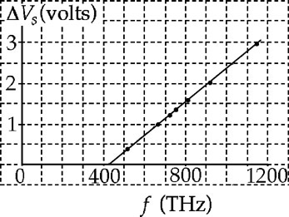

**ANS. FIG. P39.41**

and



Combining these two expressions we find:

(a) 

(b) 

(c) At the cutoff wavelength, , or



**\*P39.42 Conceptualize** Review the material in Section 39.3. We want to conceptualize the incoming x-ray as a photon, a *particle* of radiation, rather than as a *wave*.

**Categorize** We model the electron as a *nonisolated system* for *energy*. We will model the electron–photon system an *isolated system* for *momentum*.

**Analyze** From Equations 39.5 and 16.12, we can write the energy of the photon as

 (1)

where we have recognized that this is the energy transferred into a system by electromagnetic radiation. Write the appropriate reduction of Equation 8.2 for the system of the electron for a time interval spanning the collision between the incoming photon and the electron:

 (2)

where we have recognized that energy will be transferred into the system and also transferred out by electromagnetic radiation. Substitute for the energies in Equation (2):

 (3)

where **0 is the wavelength of the incoming photon, **′ is the wavelength of the scattered photon, and *Ke* is the recoil kinetic energy of the electron. Because the speed of the electron might be high, we use the relativistic form of the kinetic energy:

 (4)

Combine Equations 38.28, 39.5, and 16.12 to express the momentum of a photon in terms of its wavelength:

 (5)

Modeling the photon and the electron as an isolated system for momentum, set the initial momentum of the system equal to the final momentum for each of the two components *x* and *y*:

 (6)

 (7)

where we have used the relativistic expression for the momentum of the electron, Equation 38.19. Solve Equations (6) and (7) for the term involving angle **, square each equation, and add the equations:





where we have recognized the sum of the squares of the sine and cosine of the angle is equal to 1. Now substitute for ** :



To save some writing, define the right side of Equation (9) as *b*,



so that Equation (9) becomes

 (10)

Therefore, we can write ** as

 (11)

Now solve Equation (4) for **:

 (12)

Set Equations (11) and (12) equal, since they both express ** :

 (13)

Square both sides and substitute for *b*:





Eliminating like terms on both sides of the equation, this reduces to



**Finalize** Setting up the solution was relatively straightforward, but the algebra turned out to be a bit messy.]

Answer: See the solution.

**P39.43** From the uncertainty principle,



Therefore,



**P39.44** The definition of the Compton wavelength is = h/mec. The de Broglie wavelength is . We take the ratio of the Compton wavelength to the de Broglie wavelength, and square it:



From Equation 39.27, the momentum for a slowly-moving or rapidly-moving object is described by



Substituting and simplifying,



and 

**P39.45** (a) We find the energy of one photon:



The number intensity of photon bombardment is



(b) The density of the current the imagined electrons comprise is



(c) Many photons are likely reflected or give their energy to the metal as internal energy, so the actual current is probably a small fraction of 14.0 mA.

**P39.46** (a) To find the de Broglie wavelength of the neutron, we first determine its momentum,



Then,



(b) This is of the same order of magnitude as the spacing between atoms in a crystal.

(c) Because the wavelength is about the same as the spacing, diffraction effects should occur.

A diffraction pattern with maxima and minima at the same angles can be produced with x-rays, with neutrons, and with electrons of much higher kinetic energy, by using incident quantum particles with the same wavelength.

**Challenge Problems**

**P39.47** (a) The Doppler shift increases the apparent frequency of the incident light.

(b) If *v* = 0.280*c*,



Therefore,



(c) At *v* = 0.900*c*,



and



**P39.48** (a) At the top of the ladder, the woman holds a pellet inside a small region  Thus, the uncertainty principle requires her to release it with typical horizontal momentum  It falls to the floor in a travel time given by  as  so the total width of the impact points is



where 

To minimize  we require  or 

so 

The minimum width of the impact points is



(b) 

**P39.49** (a) Starting with Planck’s law,



the total power radiated per unit area



Change variables by letting , so .

Note that as *λ* varies from , *x* varies from .

Then,



Therefore,



(b) From part (a),





**P39.50** We show that if all of the energy of a photon is transmitted to an electron, momentum will not be conserved. In general, a photon of energy  scatters off an electron at rest, resulting in the photon having energy  and the electron having kinetic energy *Ke*. Energy conservation requires  or



If the photon is absorbed, then , and the above equation becomes

 **[1]**

Because the photon is absorbed, momentum conservation requires the momentum of the electron be in the same direction as the momentum of the original photon:

 **[2]**

From [1], we find that

 **[3]**

and  **[4]**

Substituting [3] and [4] into [2] reveals the inconsistency:



This is impossible, so all of the energy of a photon cannot be transmitted to an electron.

**P39.51** (a) Planck’s law states

.

To find the wavelength at which this distribution has a maximum, compute



Letting , the condition for a maximum becomes . We zero in on the solution to this transcendental equation by iterations as shown in the table on the following page.

|  |  |  |  |  |
| --- | --- | --- | --- | --- |
| *x* |  |  | *x* |  |
| 4.000 00 | 4.074 629 4 |  | 4.964 50 | 4.999 403 0 |
| 4.500 00 | 4.550 552 1 |  | 4.965 50 | 5.000 374 9 |
| 5.000 00 | 5.033 918 3 |  | 4.965 00 | 4.999 889 0 |
| 4.900 00 | 4.936 762 0 |  | 4.965 25 | 5.000 132 0 |
| 4.950 00 | 4.985 313 0 |  | 4.965 13 | 5.000 015 3 |
| 4.975 00 | 5.009 609 0 |  | 4.965 07 | 4.999 957 0 |
| 4.963 00 | 4.997 945 2 |  | 4.965 10 | 4.999 986 2 |
| 4.969 00 | 5.003 776 7 |  | 4.965 115 | 5.000 000 8 |
| 4.966 00 | 5.000 860 9 |  |  |  |

The solution is found to be

 and 

(b) Thus,



This result agrees with Wien’s experimental value of  for this constant.

|  |
| --- |
| **ANSWERS TO QUICK-QUIZZES** |

1. (b)

**2.** Sodium light, microwaves, FM radio, AM radio.

**3.** (c)

**4.** The classical expectation (which did not match the experiment) yields a graph like the following drawing:

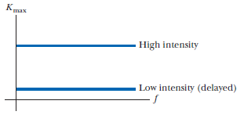

**5.** (d)

**6.** (c)

**7.** (b)

**8.** (a)

|  |
| --- |
| **ANSWERS TO EVEN-NUMBERED PROBLEMS** |

**P39.2** (a) 999 nm; (b) The wavelength emitted at the greatest intensity is in the infrared (greater than 700 nm), and according to the graph in Active Figure 40.3, much more energy is radiated at wavelengths longer than  than at shorter wavelengths.

**P39.4** (a) 5 200 K; (b) This is not blackbody radiation.

**P39.6** i: (a) 2.57 eV, (b) 1.28 × 10−5 eV, (c) 1.91 × 10−7 eV; ii: (a) 484 nm, (b) 9.68 cm, (c) 6.52 m; iii: (a) visible light (blue), (b) radio wave, (c) radio wave

**P39.8** (a) 7.09 × 104 W; (b) 580 nm; (c) 7.99 × 1010 W/m; (d−i) See table in P40.12; (j) 

**P39.10** See P39.10 for full explanation.

**P39.12** (a) 148 days; (b) The result for part (a) does not agree at all with the experimental observations.

**P39.14** (a) 8.27 eV; (b) The photon energy is larger than the work function;   
(c) 1.92 eV; (d) 1.92 V

**P39.16** (a and b) See P39.16 for full answer; (c) 180°. We could answer like this: The photon imparts the greatest momentum to the originally stationary electron in a head-on collision. Here the photon recoils straight back, and the electron has maximum kinetic energy.

**P39.18** (a) 64.4° (b) 0.120 nm

**P39.20** (a) ; (b) 

(c) 

**P39.22** (a) It is because Compton’s equation and the conservation of vector momentum give three independent equations in the unknowns , , and *u*; (b) 3.82 pm

**P39.24** (a) 14.0 kV/m; (b)  (c) 4.19 nN; (d) 10.2 g

**P39.26 (a) , ; (b) **

**P39.28** (a) ~108 eV; (b) ~ −106 eV; (c) The electron could not be confined to the nucleus.

**P39.30** (a) See P39.30 (a) for full explanation; (b) They will always have a different frequency from photons of the same wavelength

**P39.32 (a)  ; (b)** See P39.32(b) for full explanation

**P39.34** 6.37 × 10–11 A

**P39.36** 3.22 × 10–22 s

**P39.38** See P39.38 for full explanation

**P39.40** See P39.40 for full explanation

**P39.42** See the solution.

**P39.44** See P39.44 for full explanation

**P39.46 (a) ; (b)** This is of the same order of magnitude as the spacing between atoms in a crystal.**; (c)** Because the wavelength is about the same as the spacing, diffraction effects should occur.

**P39.48 (a) ; (b) **

**P39.50** See P39.50 for full explanation